A-dec Sterilization Center 594 Series

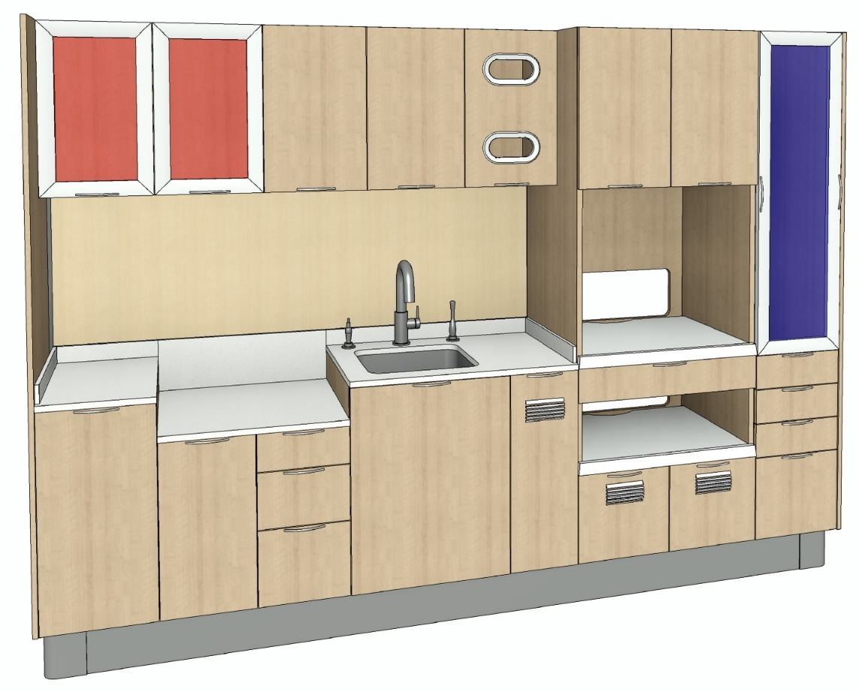

A-dec 594 AutoCAD 3D configurations can be assembled in a project quickly by placing each Dynamic block component in place, select the block, then select the options available for that particular component.

Begin by inserting the appropriate subbase block, highlight, then select the necessary length from the Properties menu or the dynamic block triangle grip.

The lower cabinets and tower cabinets have a lower left basepoint for building a configuration from left to right. Insert the lower cabinet components and/or towers by inserting at position nodes, highlighting the block, then selecting the optional configuration. When the lower cabinet configuration is complete, insert the Show Wall followed by the Countertop.

The Show Wall block is a 2D dynamic closed polygon to be extruded after dragging to length.

* Insert at left rear start point
* Select the block and drag the grip to the appropriate position node for length
* Explode the block and extrude to the thickness position node or .8031”
* Highlight and change the layer of the Show Wall solid to “Cabinet Panel” in the Properties menu

Sink module (SK400X) and Ultrasonic Cleaning (ergonomic) module (EQ4202) blocks contain a solid for the purpose of subtracting a cutout in the Countertop:

* Insert into position and select the component option
* Explode the block and the Countertop block
* Subtract the hidden line solid from the Countertop

The Large Instrument Washer module (EQ4301) block includes a solid to be subtracted from the Subbase.

* Insert into position and select the component option
* Explode the block and the Subbase block
* Subtract the hidden line solid from the Subbase

Upper Cabinet blocks have a basepoint at the top left corner for positioning.

Endcap blocks have a basepoint at the back corner of the endcap on the side that meets the cabinets.

Materials should be applied “BYLAYER” with the MATERIALATTACH command.

|  |  |  |
| --- | --- | --- |
| **AutoCAD file name** | **Order P/N** | **Option within Dynamic Block** |
| Cabinet-Adec-594_Countertop_Corner.dwg | CS/CQ4004 | 112” Corner Countertop, Left/Right |
| CS/CQ4005 | 126” Corner Countertop, Left/Right |
| CS/CQ4006 | 140” Corner Countertop, Left/Right |
| CS/CQ4007 | 154” Corner Countertop, Left/Right |
| CS/CQ4008 | 168” Corner Countertop, Left/Right |
| Cabinet-Adec-594_Countertop_Straight.dwg | CS/CQ4001 | 70” Straight Countertop |
| CS/CQ4002 | 84” Straight Countertop |
| CS/CQ4003 | 98” Straight Countertop |
| CS/CQ4004 | 112” Straight Countertop |
|  | CS/CQ4005 | 126” Straight Countertop |
|  | CS/CQ4006 | 140” Straight Countertop |
|  | CS/CQ4007 | 154” Straight Countertop |
| CS/CQ4007 | 168” Straight Countertop |
| Cabinet-Adec-594_End_Cap.dwg | EC4001 | Curved End Cap, Left |
| EC4001 | Curved End Cap, Right |
|  | EC4002 | Flat End Cap w/Filler Panel, Left |
| EC4002 | Flat End Cap w/Filler Panel, Right |
| Cabinet-Adec-594_Lower_Cabinet_10.dwg | DR4001 | 10” Door |
|  | DR4002 | 10” Door, Interior Drawer |
|  | EQ4002 | 10” Dryer |
| Cabinet-Adec-594_Lower_Cabinet_14.dwg | DB4001 | 14” Slide-out Waste Drawer |
|  | DB4002 | 14” Slide-out Waste Drawer, Servo |
|  | DB4005 | 14” 5 Drawer |
|  | DB4006 | 14” 4 Drawer |
|  | DR4001 | 14” Door |
|  | DR4002 | 14” Door, Interior Drawer |
| Cabinet-Adec-594_Lower_Cabinet_24.dwg | EQ4201 | 24” Ultrasonic Cleaning |
|  | EQ4202 | 24” Ultrasonic Cleaning, Ergonomic |
|  | EQ4301 | 24” Large Instrument Washer |
| Cabinet-Adec-594_Lower_Cabinet_28.dwg | DB4005 | 28” 5 Drawer |
| DB4006 | 28” 4 Drawer |
|  | EQ4201 | 28” Ultrasonic Cleaning |
|  | EQ4202 | 28” Ultrasonic Cleaning, Ergonomic |
|  | EQ4204 | 28” Small Instrument Washer |
| Cabinet-Adec-594_Lower_Cabinet_Corner.dwg | EQ4100 | 28” Corner Lower |
| EQ4101 | 28” Corner Panel |

|  |  |  |
| --- | --- | --- |
| Cabinet-Adec-594_Lower_Cabinet_Sink.dwg | SK4001 | 22” Sink |
|  | SK4002 | 22” Sink, Ancillary 1-3/8” Cutout |
|  | SK4003 | 22” Sink, HVE and Syringe |
|  | SK4004 | 22” Sink, HVE and Syringe, Ancillary 1-3/8” Cutout |
| Cabinet-Adec-594_Make Ready_14.dwg | TW4200 | 14", 5 Drawers, Wood Door |
|  | TW4201 | 14", 5 Drawers, Aluminum Door |
|  | TW4202 | 14", 4 Drawers, Wood Door |
|  | TW4203 | 14", 4 Drawers, Aluminum Door |
| Cabinet-Adec-594_Make Ready_28.dwg | TW4200 | 28", 5 Drawers, Wood Door |
| TW4201 | 28", 5 Drawers, Aluminum Door |
| TW4202 | 28", 4 Drawers, Wood Door |
|  | TW4203 | 28", 4 Drawers, Aluminum Door |
| Cabinet-Adec-594_Show_Wall.dwg | WA40xx | Place and drag length per configuration |
| Cabinet-Adec-594_Sterile Storage_14.dwg | TW4103 | Aluminum Doors, Servo Activated |
| TW4104 | Aluminum Doors, Manual |
| TW4107 | 4 Drawers, Aluminum Doors, Servo |
| TW4108 | 4 Drawers, Aluminum Doors, Manual |
| Cabinet-Adec-594_Sterilization Tower_28.dwg | TW4001 | Dual Chamber, Wood Doors |
| TW4002 | Chamber and Cassette, Wood Doors |
| TW4003 | Chamber and 4 Drawers, Wood Doors |
| TW4005 | Dual Chamber, Aluminum Doors |
| TW4006 | Chamber and Cassette, Aluminum Doors |
| TW4007 | 28" Wide, Chamber and 4 Drawers, Aluminum Doors |
| Cabinet-Adec-594_Subbase_Corner.dwg | SB40xx | Multiple length Subbases |
| Cabinet-Adec-594_Subbase_Straight.dwg | SB40xx | Multiple length Subbases |
| Cabinet-Adec-594_Subbase_U.dwg | SB40xx | Multiple length Subbases |
| Cabinet-Adec-594_Upper_14.dwg | UP4009 | 14” Wood Door |
| UP4010 | 14” Aluminum Door |
| Cabinet-Adec-594_Upper_28.dwg | UP4002 | 28", Aluminum Doors, Servo Activated (Red) |
|  | UP4003 | 28", Wood Doors, Manual |
|  | UP4004 | 28", Aluminum Doors, Manual (Red) |
|  | UP4007 | 28", Wood Doors, Left Dispenser |
|  | UP4007 | 28", Wood Doors, Right Dispenser |
|  | UP4008 | 28", Aluminum Doors, Left Dispenser |
|  | UP4008 | 28", Aluminum Doors, Right Dispenser |
|  | UP4011 | 28", Aluminum Doors, Manual |
| Cabinet-Adec-594_Upper_Corner.dwg | UP4200 | 28”, Wood Door |
| UP4201 | 28”, Aluminum Door |

|  |  |
| --- | --- |
| **Recommended Configuration Starting Point Assemblies** | |
| Cabinet-Adec-594001.dwg | 594 112” Straight Sterilization Center (left to right process) |
| Cabinet-Adec-594002.dwg | 594 126” Straight Sterilization Center (left to right process) |
| Cabinet-Adec-594003.dwg | 594 140” Straight Sterilization Center (left to right process) |
| Cabinet-Adec-594004.dwg | 594 140 x 56” Galley Sterilization Center (right to left process) |
| Cabinet-Adec-594005.dwg | 594 140 x 112” L-shaped Sterilization Center (right to left process) |